M.Tech (IS)

Cognitive Systems Group Project

NUS ISS Chatbot Agent

Team Members

SUDALAIANDI RAJA SUDALAIMUTHU

JAYARAMAN REVATHI

JAYASRI RAGHUNATHAN

SUNIL VARGHESE

# EXECUTIVE SUMMARY

NUS ISS offers a multitude of degree and professional conversion programs which are very popular not only in Singapore but also in many of the south east Asian and south Asian countries. Even within Singapore, IT is becoming a most sought-after subject, because of the emerging state-of-the-art technologies and the job and start up opportunities it provides.

The Singapore Government is making significant fund allocation for Skill future credits in its push for a smart nation. It aims to develop Infocom leaders who can achieve business & organisation innovation and also to ensure enough talent pool of employees for multinational companies in the thriving economy.

In order to meet the growing national and international demand, our team of 4 Singapore residents are tasked with building a chat bot which can handle queries of the aspiring students. This chatbot will provide a friendly user interface and will respond to users queries on ISS programs, courses and related information

Project Git Repository : <https://github.com/aivoyagers/IRS-RS-2019-03-09-IS1PT-GRP-aiVoyagers-irs-Intelligent-Rapid-Shuttle.git>

# BUSINESS PROBLEM BACKGROUND:

With multitude of courses offered, easy retrieval of relevant information is always challenging. The chatbot eases the effort for gathering information, through an intuitive natural language interface

# PROJECT OBJECTIVE

Having defined the business problem, our group’s aim was:

To develop a user-friendly chatbot, which can provide rapid and relevant responses on the curriculum offered by NUS ISS. This will minimize efforts and time of the browsing multiple webpages. When the user make enquires t such as course schedule and fee, the chatbot will recognize the intent and the entities and respond accordingly.

The Chatbot has built in voice and text-based conversational interfaces. It contains voice recognition, [natural language understanding](https://en.wikipedia.org/wiki/Natural_language_understanding), and text-to-speech. api.ai offers a web interface to build and test conversation scenarios.

# PROJECT SOLUTION

## BACKGROUND KNOWLEDGE AND USER INPUTS

For this project, below data/input are given/predefined:

User Input:

* Query on a specific ISS program

Data Collected from by web scrapping of ISS website on the following

* Executive Education
* Graduate Programmes
* Stackable Certificate programmes

## SYSTEM ARCHITECTURE

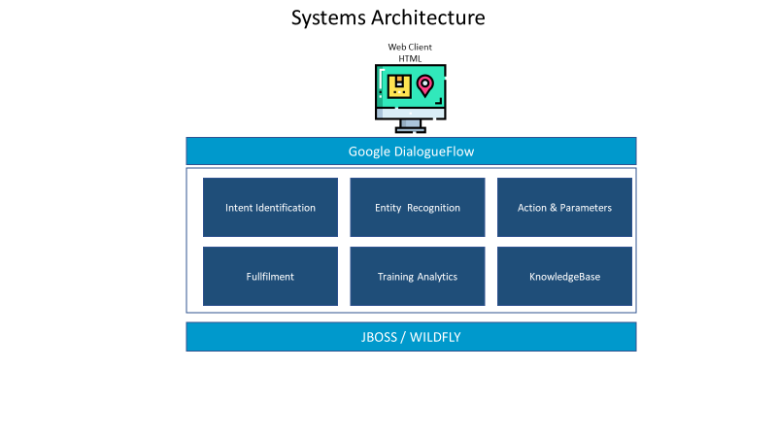

Below are the list of System components involved as part of this project.

* **ISS Chatbot** is built using HTML/JavaScript to interact with user to get the user inquiry
* Google DialogueFlow will identify the intent and retrieve the information relevant to the entity present in the user input and return the response based on the information in the knowledgebase

# PROJECT SCOPE

Project scope is to develop, integrate and demonstrate speech and text recognition techniques by delivering a chatbot application. Objective is to demonstrate understanding of the concepts learnt in Cognitive Systems module as part of M.Tech (Intelligent Systems) graduate programme.

The scope of the project is limited to the following topics of the ISS website in the executive education, graduate programmes and stackable certificate programmes

ISS Chatbot project scope covers following minimum viable product features.

* A web user interface to accept user enquiry on the ISS programs offered
* It the recognise user intent as on ISS programs and identifies the entity
* If it can’t identify the intent, it will provide the Fallback intent

# SYSTEM’S FEATURES

The key features of the System are as follows:

* It has a webpage for getting the user input either in the form of voice or text
* The chatbot will perform natural language understanding to understand the intent of the user’s query.
* Once it identifies the intent, it will fill the slots by recognizing the entities of the query.
* It will retrieve the relevant information from the knowledge base and provide response to the user
* The bot will perform training on the sample utterance to understand the intent and entity
* Utterance are made up of key word commands, natural speech like filler words and entities/parameters for the information that varies. One of the most important aspects of designing a voice experience is defining the range of what people might say

## ISS Bot – Sample Screen for the Data Input provided in Section 6.2 Sample Input

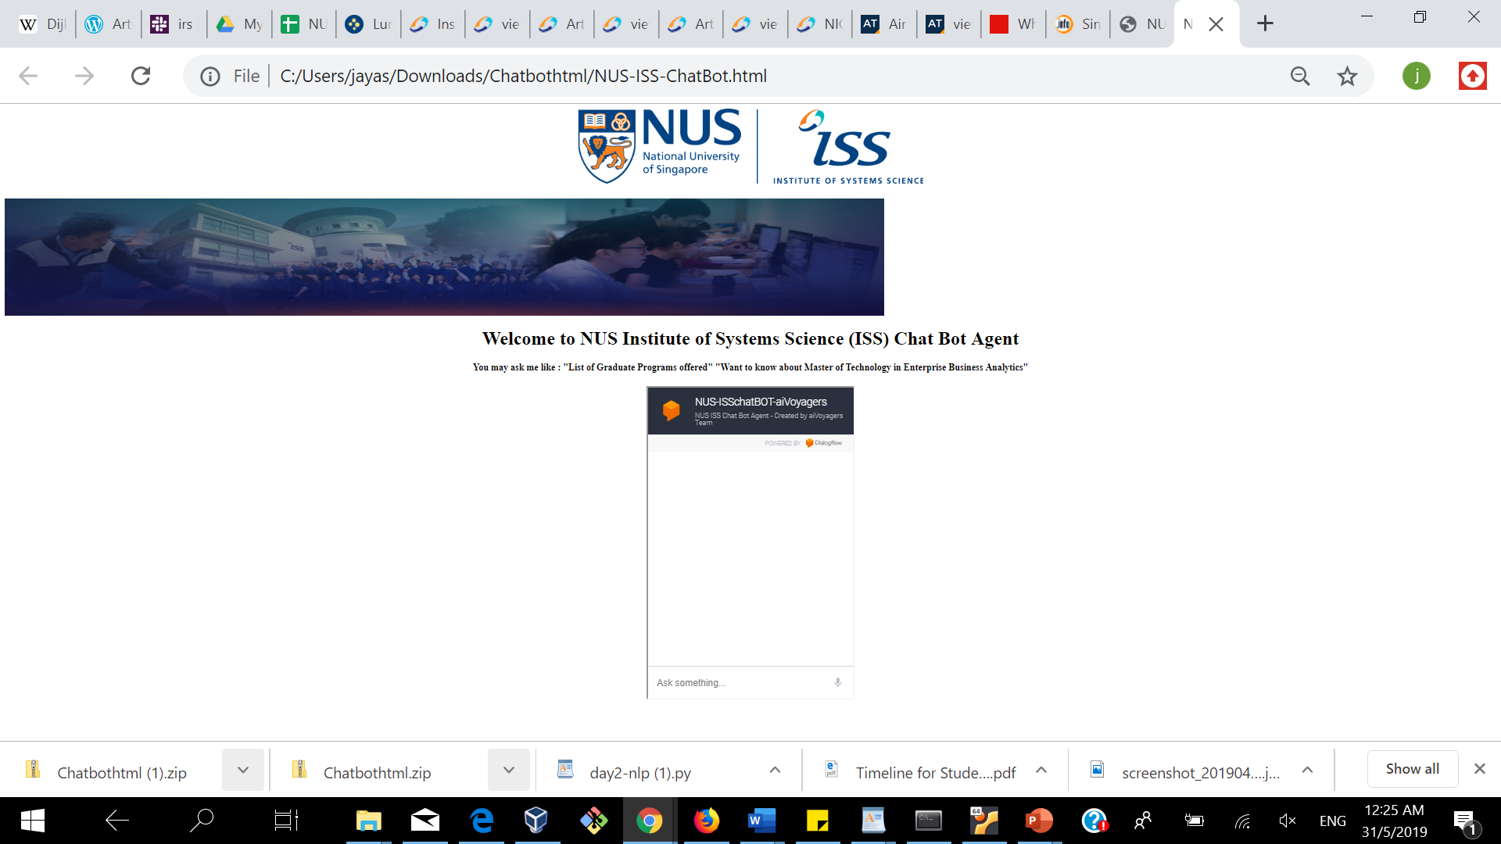

## ISS Chatbot Solution – Sample Input

## Graduates Are Hired By Companies like?

## ISS Chatbot – Sample Output

## IBM

## OCBC Bank

## Tan Tock Seng Hospital

## Singtel

## Singapore Pools

# LIMITATIONS

System will respond based in the information in the knowledge base. While it can answer individual questions, it will not be able to engage in a continuous dialogue, based on the previous answer. It will not answer questions other than the 3 topics mentioned earlier. This is due to the limited time available to web scrapping of the ISS website

# CONCLUSION

Our team had a great time working on this project, and we definitely picked up some useful skills along the way. Understanding the configuration of Dialogue flow, providing training utterances, annotating the entities and integrating the knowledge base. Without a sound knowledge base taught in the lectures, we wouldn’t have been able to build on system based on all the different rules.

IMPROVEMENTS

Following are the improvements noted while executing this project.

* To engage in a continuous dialogue, by answering questions based on the previous answer
* To provide response on all the information available in the ISS website
* Compare with courses offered by other universities